|  |
| --- |
| **Soap to REST Scenario** |
| **Version: 1.0** |

Table of Contents

**1.** **Creating the Iflow for Soap to REST** 3

**Document Control**

**Revision History:**

|  |  |  |  |  |
| --- | --- | --- | --- | --- |
| **Version** | **Date** | **Author(s)** | **Reviewer** | **Revision Notes** |
| 1.0 |  |  |  |  |
|  |  |  |  |  |
|  |  |  |  |  |

# **Creating the Iflow for Soap to REST**

Step 1: Create the Iflow under your package.

Step 2: User the naming convention as Soap_to_Rest_<userid>.

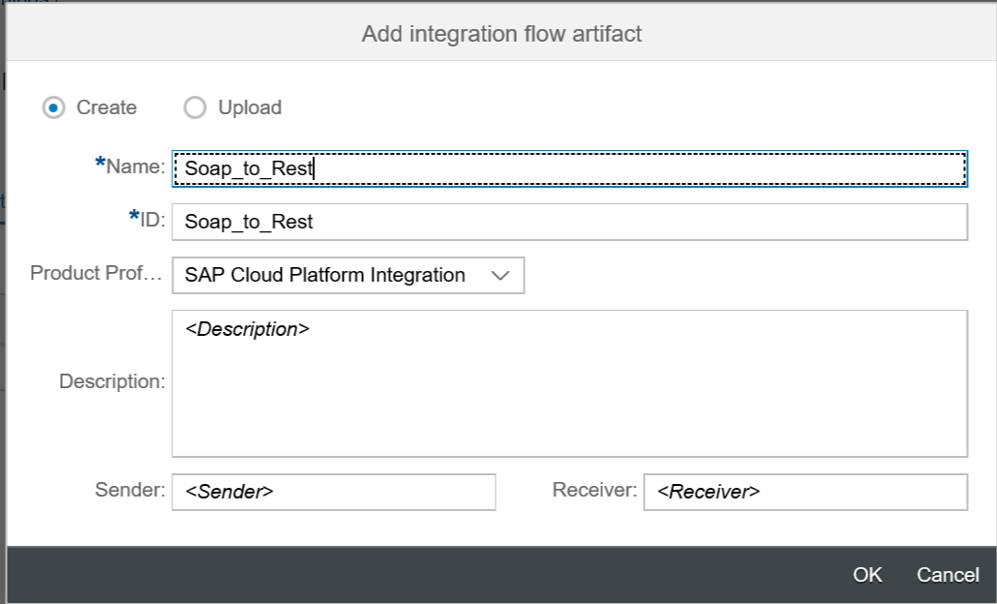

Step 3: Open the IFlow and remove the Sender and Receiver participants, rename the Integration Process to Soap_To_Rest. No modifications needed in Processing Tab.

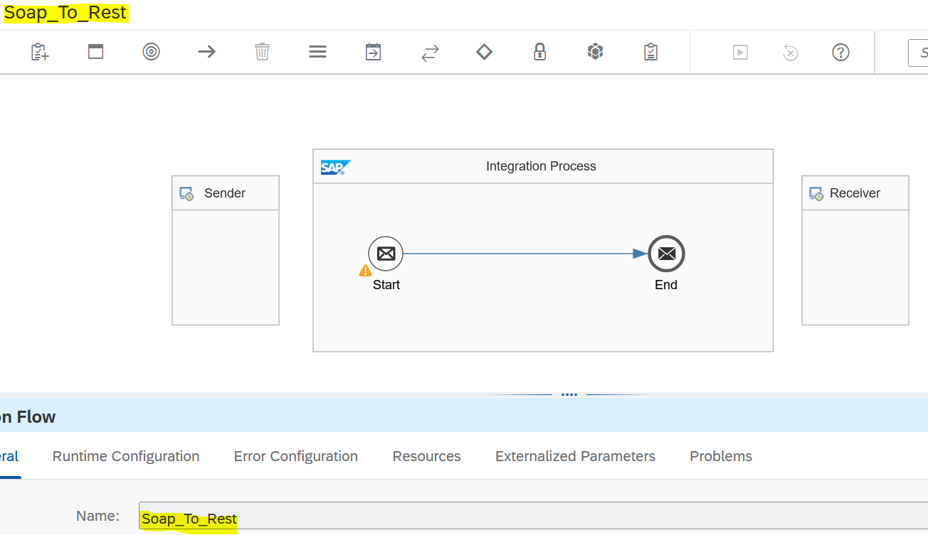

Step 4: Click on sender, drag the (->) forward arrow towards start. It will automatically pop up the below snapshot.

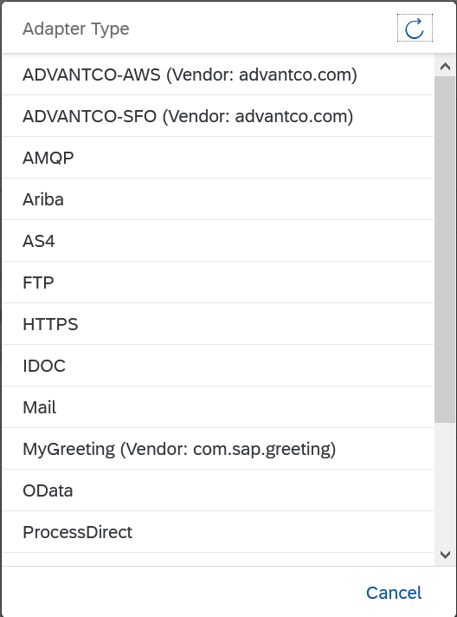

Step 5: Select Soap adapter type and message protocol as soap 1.x.

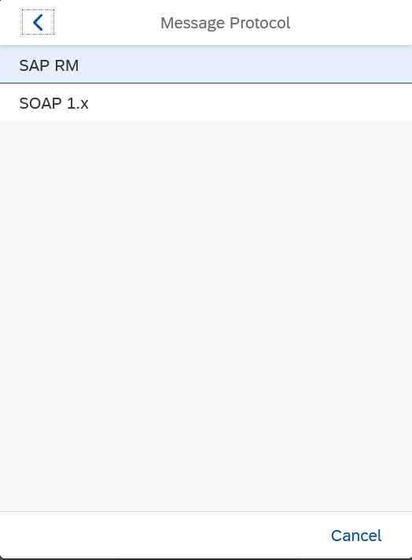

Step 6: Click on the Soap adapter, it will show like below snapshots.

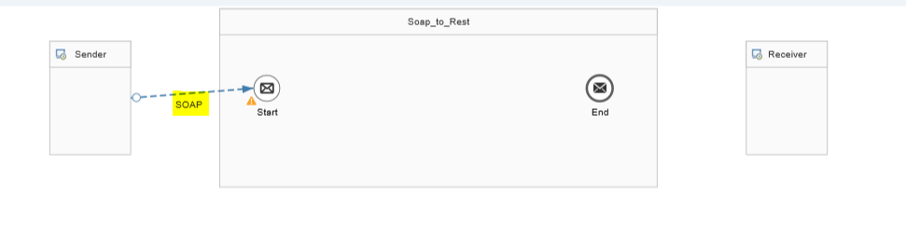

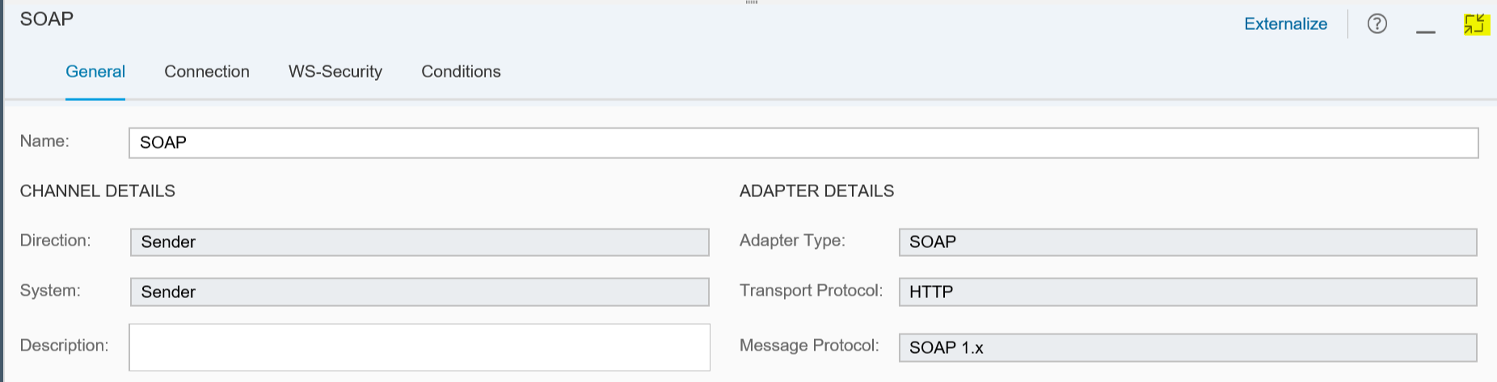

Step 7: Goto connection tab, give address as /test/soap1

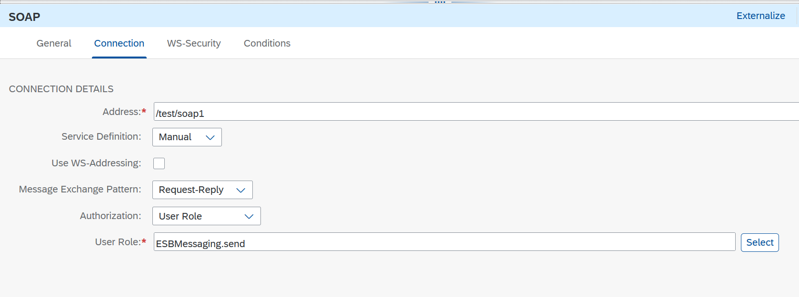

Remaining all tabs (WS-Security, Conditions) default.

Step 8: Goto pallet drag and drop the content modifier in that goto header tab and do it as below and then goto pallet and drag and drop request reply into canvas. Call->external call->request reply.

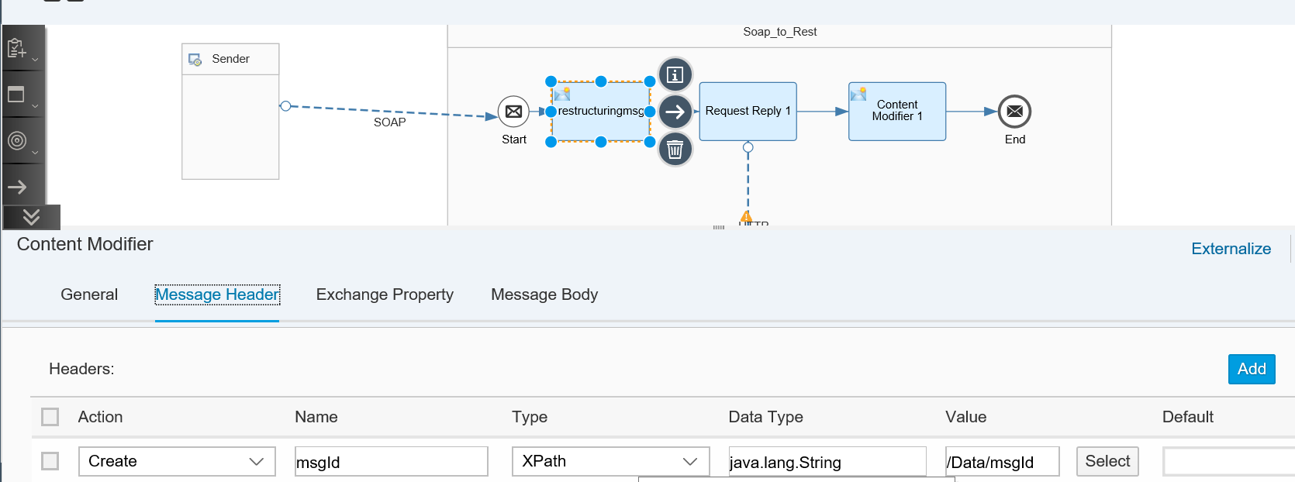

In above snap we are capturing the msgId coming from the input message using Xpath.

Then request reply,

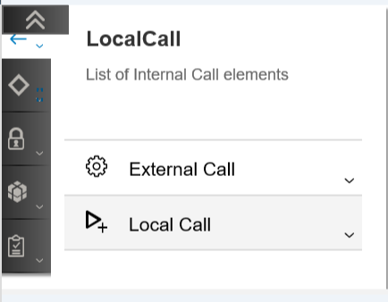

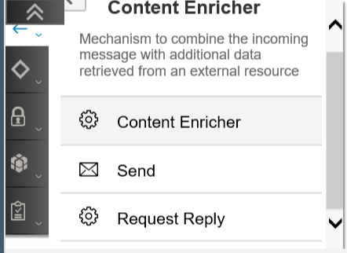

Step 9: now the canvas looks like below.

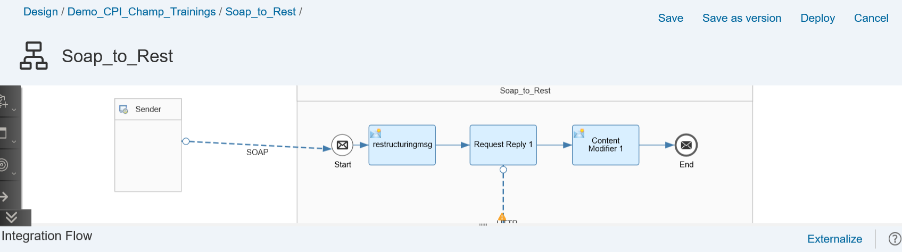

Step 10: click on request reply and drag and drop towards receiver,get the pop up, select the http as receiver adapter as looks like below

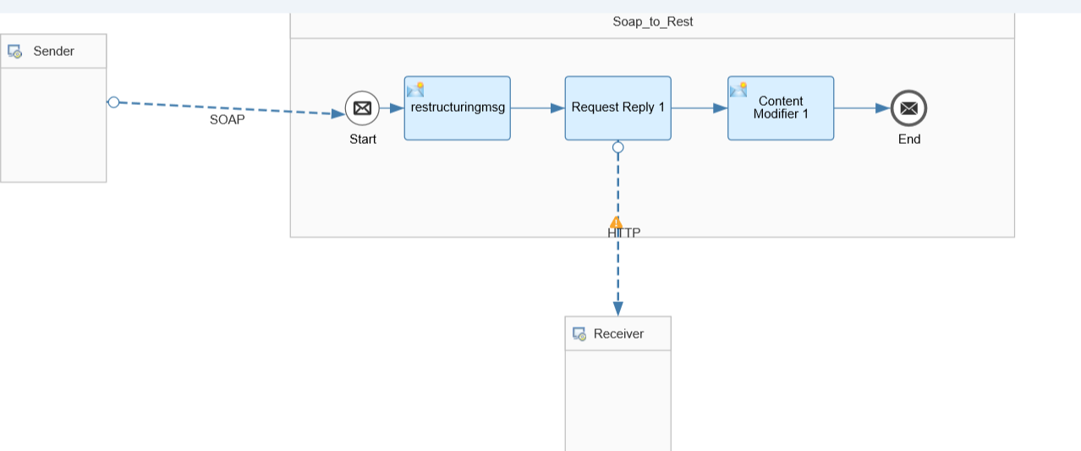

Step 11: click on http, for adapter.

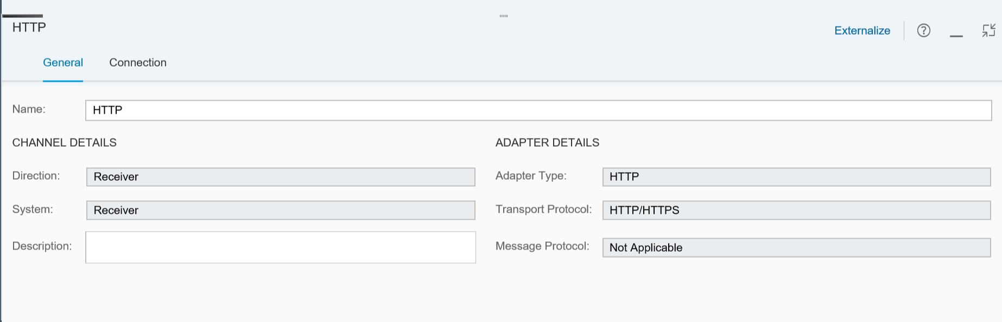

In connection, mention the receiver url

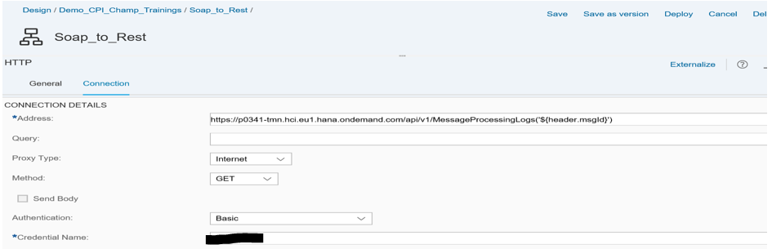

Step 12: Drag drop the content modifier into canvas from the pallet.

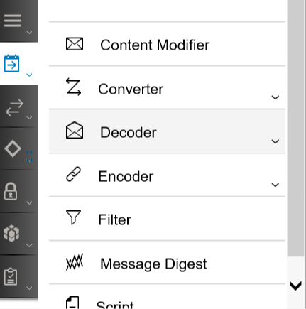

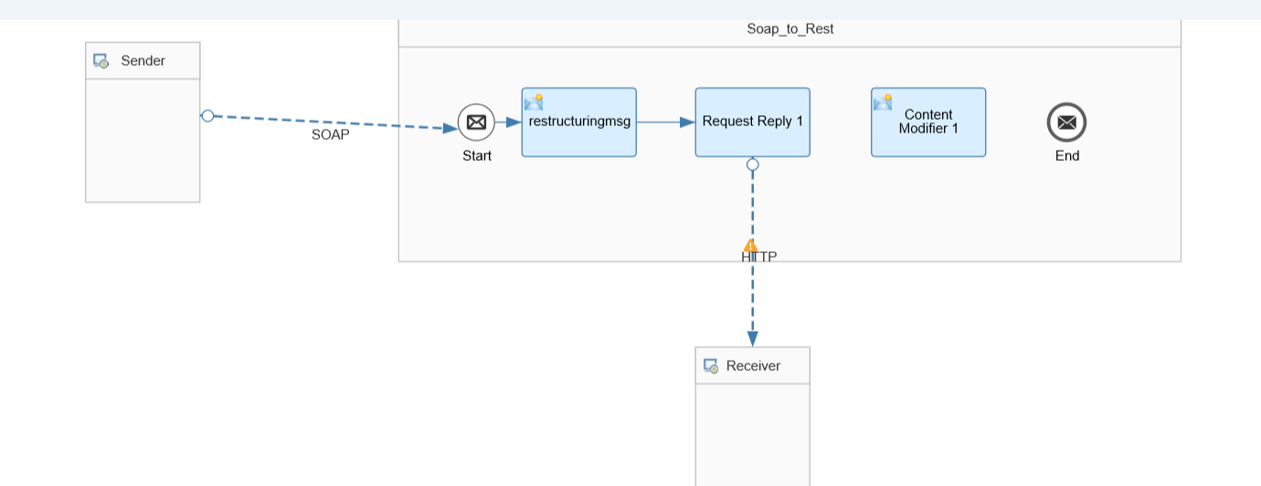

Click on content modifier goto body tab and enter as below;

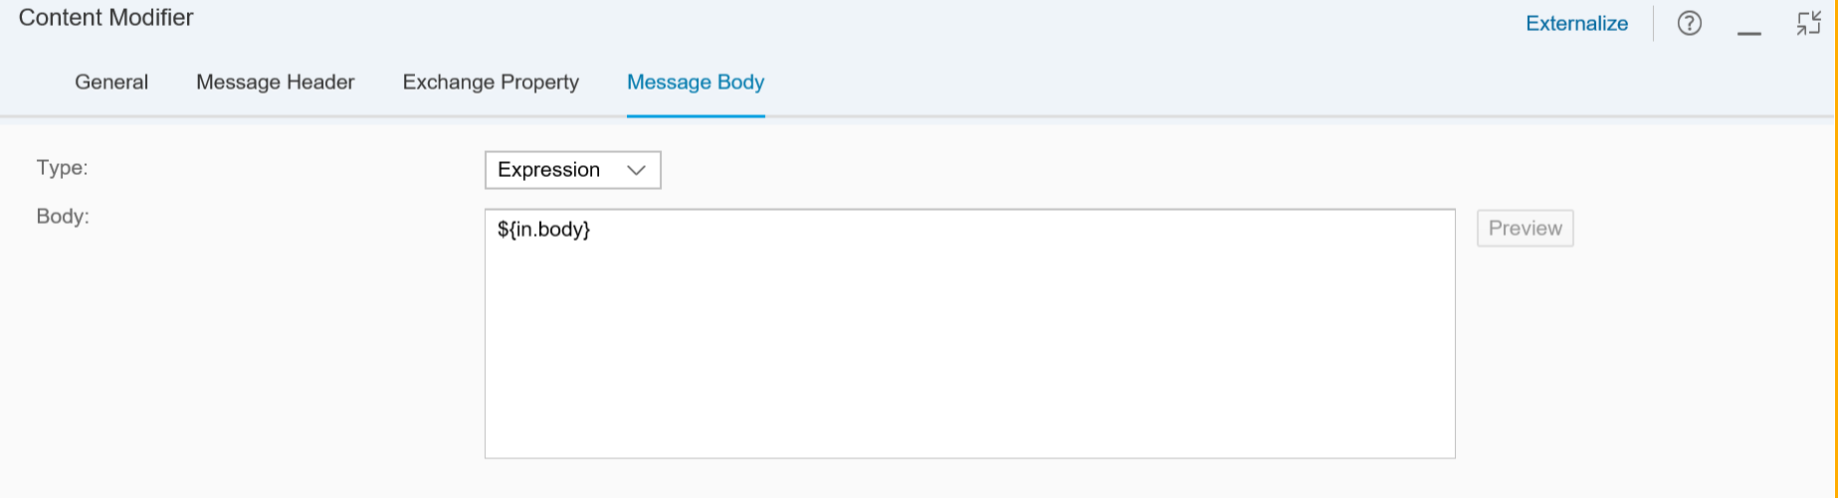

Now request reply drag the the forward arrow towards content modifier.

Similar way click on content modifier drag drop towards end. Final screen appears as below.

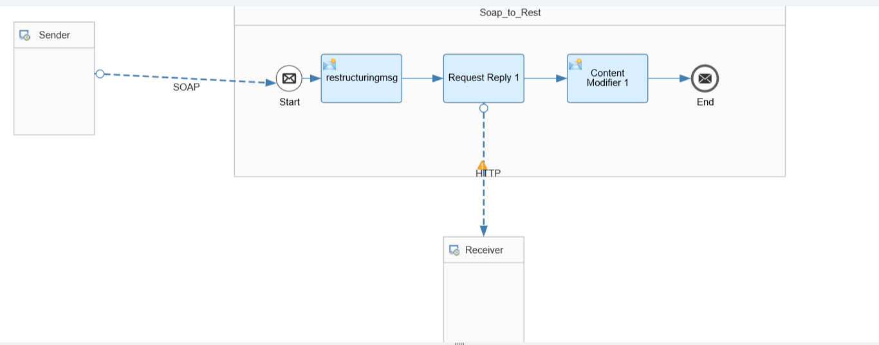

Then click on save and deploy the integration flow.

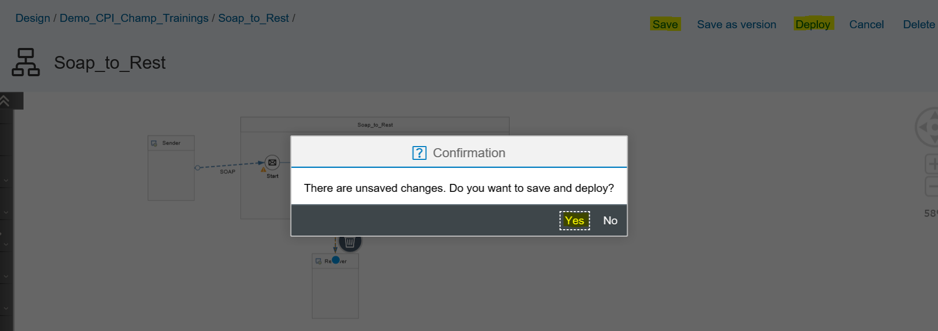

Click yes.

Now goto monitoring page, goto click on your scenario soap to rest

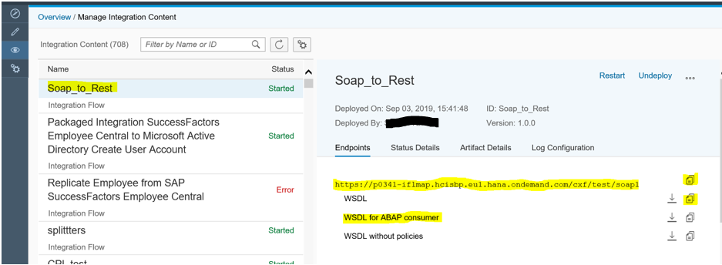

Download the WSDL for ABAP consumer.

Testing: Open SOAP UI. Click on new soap project. Get below pop up

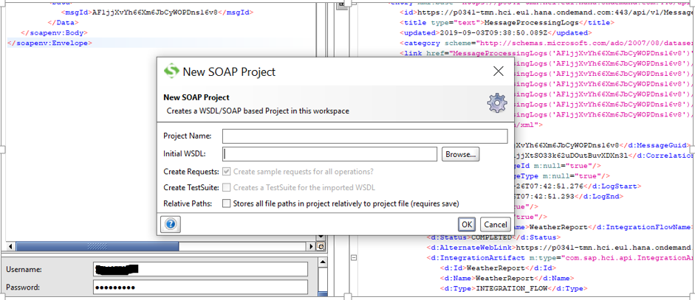

Browse the wsdl you downloaded above

Now open the request and edit as below.

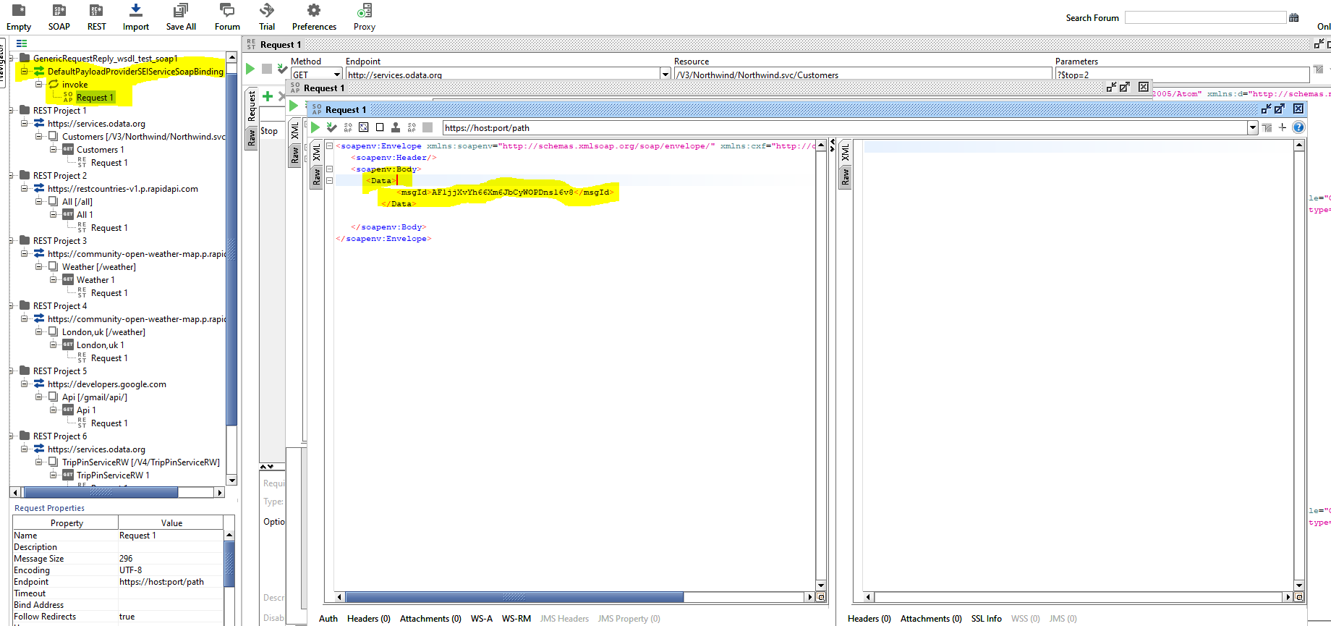

And in the URL copy the URL from CPI monitoring and paste here.

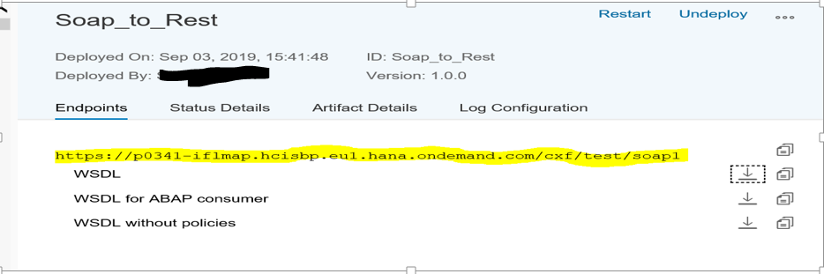

In soap ui,

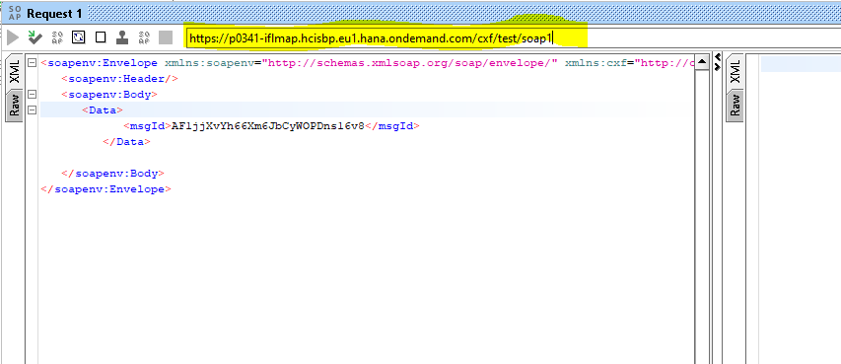

Later provide you tenant logins for basic authentication as shown below.

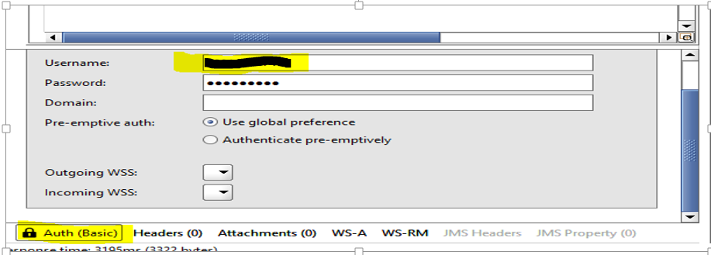

Now trigger the flow by forward button

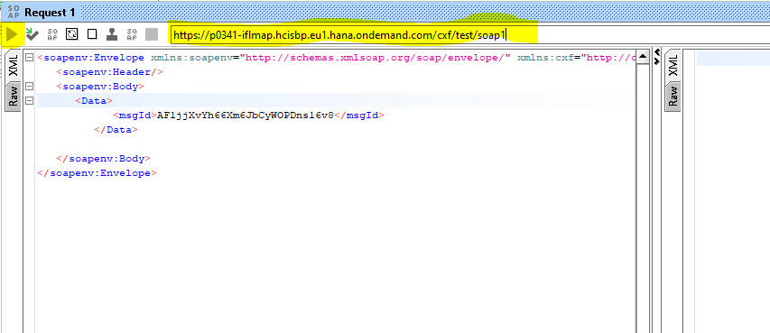

You will get response in response window as below,

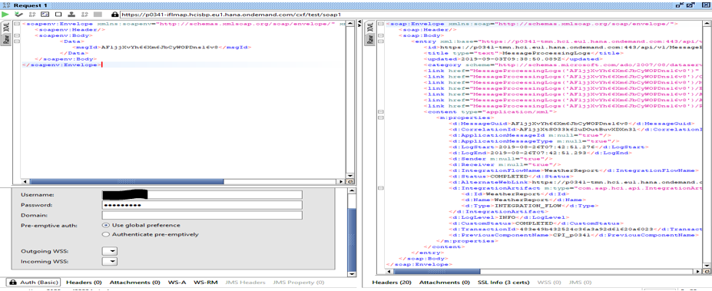

Now got CPI monitoring open the logs. Click on message processing

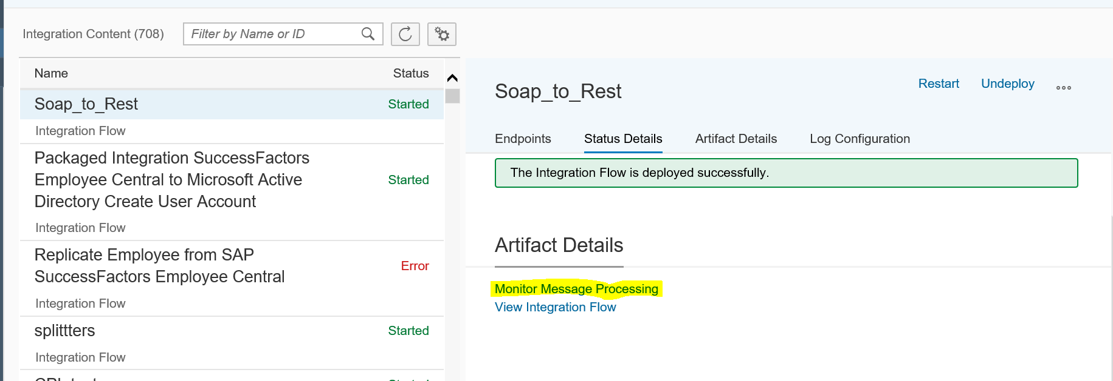

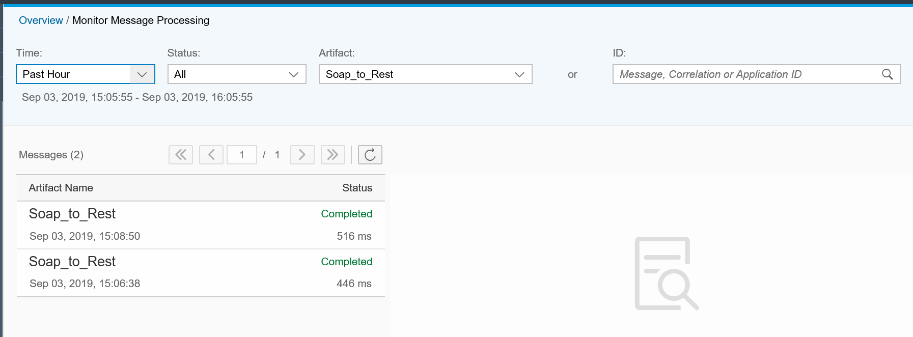

Click on the messages to check the details. Thank you!!